Employment Status Analysis (Categorical Outcome)

Objective
This section examines the association between Language Proficiency, Education Level, and Internship Experience with Employment Status among international graduates.
Chi-square tests of independence were applied to determine statistical significance, and Cramér’s V was computed to measure the strength of association.
Combined predictor analyses (e.g., Language × Education) were used to explore interaction effects between factors.

Methodology
- Chi-square Test of Independence (χ²): tested whether Employment Status is independent of each predictor.
- Cramér’s V: quantified effect size (0 = no association, 1 = perfect association).
- Combined Predictors: joint categories (e.g., Language × Education, Education × Internship) captured interaction effects.
- Visualization: heatmaps show distribution patterns across employment outcomes (Employed, Unemployed, Continuing Education).
All analyses were conducted in Python using pandas, scipy.stats, and seaborn.

Results and Interpretation

Individual Predictors
Figure 1. Language Proficiency vs Employment Status
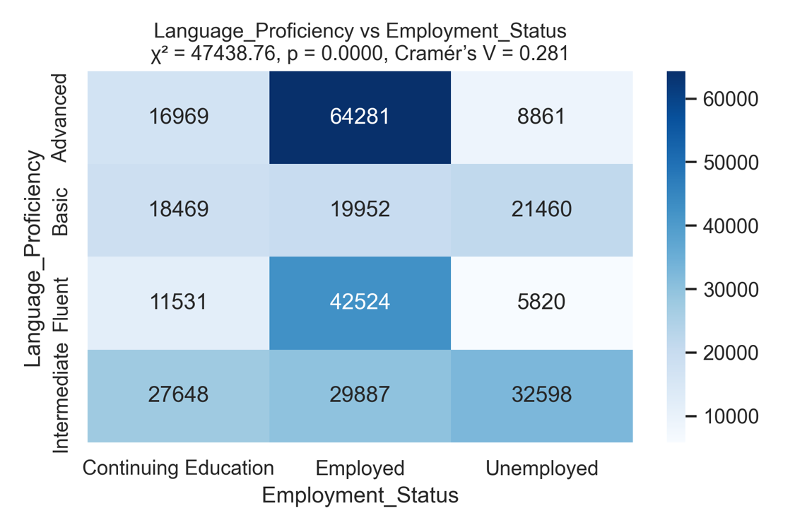
χ² = 47 438.76, p < 0.001, Cramér’s V = 0.281
Graduates with advanced language proficiency have the highest employment rates, whereas those with basic or intermediate proficiency show higher proportions of continuing education or unemployment.

Figure 2. Education Level vs Employment Status
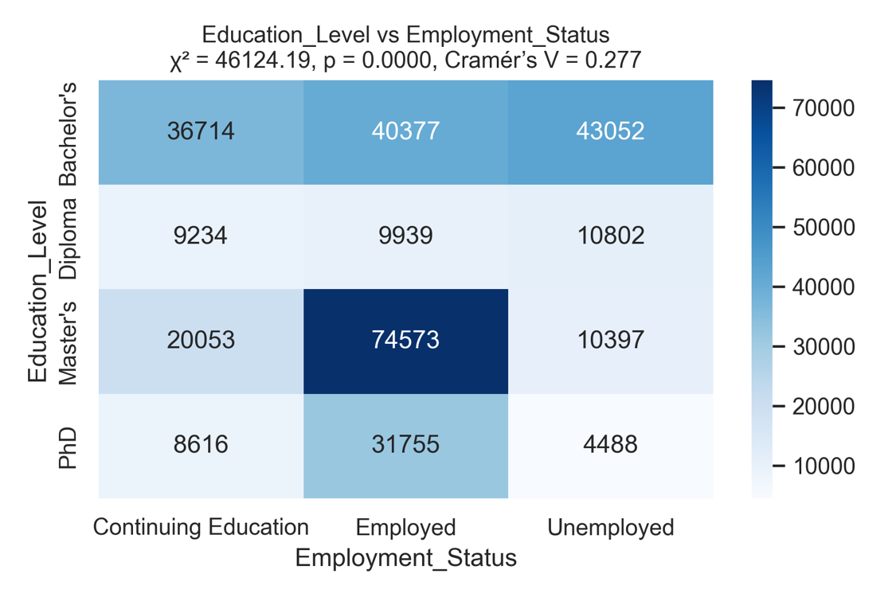
χ² = 46 124.19, p < 0.001, Cramér’s V = 0.277
Graduates with a Master’s degree display the highest employment rates. Diploma and PhD holders are more likely to pursue further study.

Figure 3. Internship Experience vs Employment Status
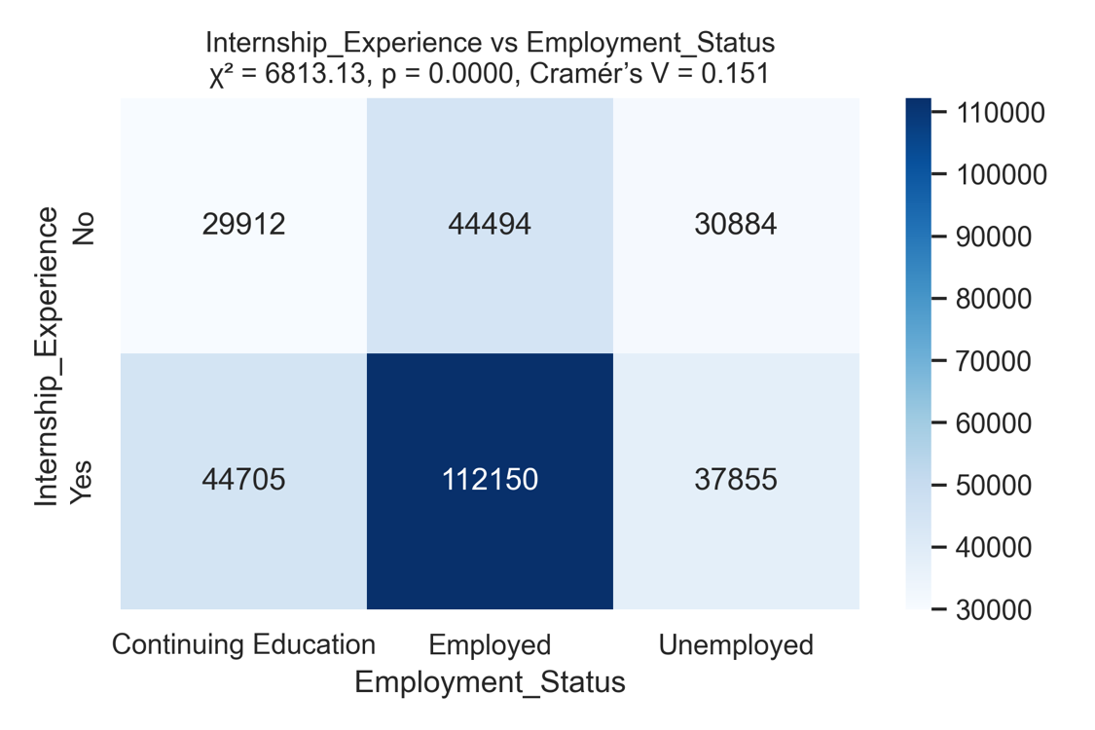
χ² = 6 813.13, p < 0.001, Cramér’s V = 0.151
Graduates with internship experience are considerably more likely to be employed, confirming the career benefit of practical experience.

Combined Predictors
Figure 4. Language Proficiency × Education Level vs Employment Status
(Insert file → Language_Proficiency × Education_Level_vs_Employment_Status.png)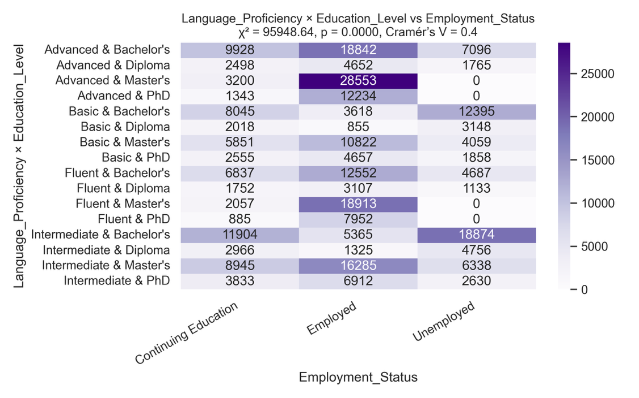
χ² = 95 948.64, p < 0.001, Cramér’s V = 0.400
This interaction shows the strongest relationship. Graduates with advanced language skills and Master’s degrees have the highest employability.

Figure 5. Language Proficiency × Internship Experience vs Employment Status
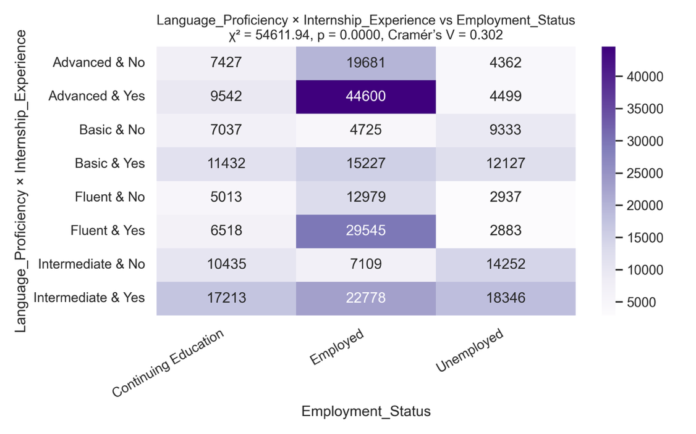
χ² = 54 611.94, p < 0.001, Cramér’s V = 0.302
Combining advanced language skills with internship experience further improves employment prospects.

Figure 6. Education Level × Internship Experience vs Employment Status
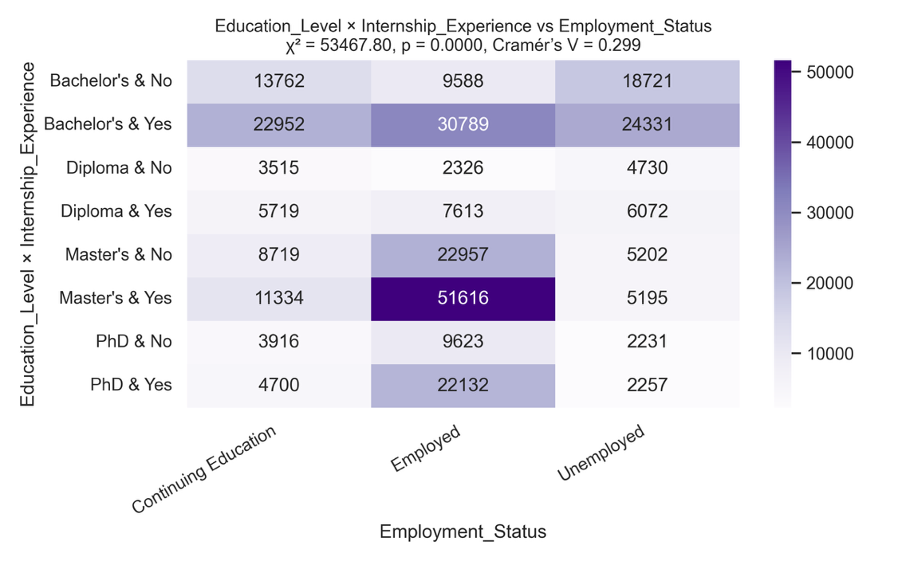
χ² = 53 467.80, p < 0.001, Cramér’s V = 0.299
Graduates holding Master’s degrees and internship experience show the highest employment outcomes.

Figure 7. Ranked Cramér’s V Heatmap – Strength of Association with Employment Status
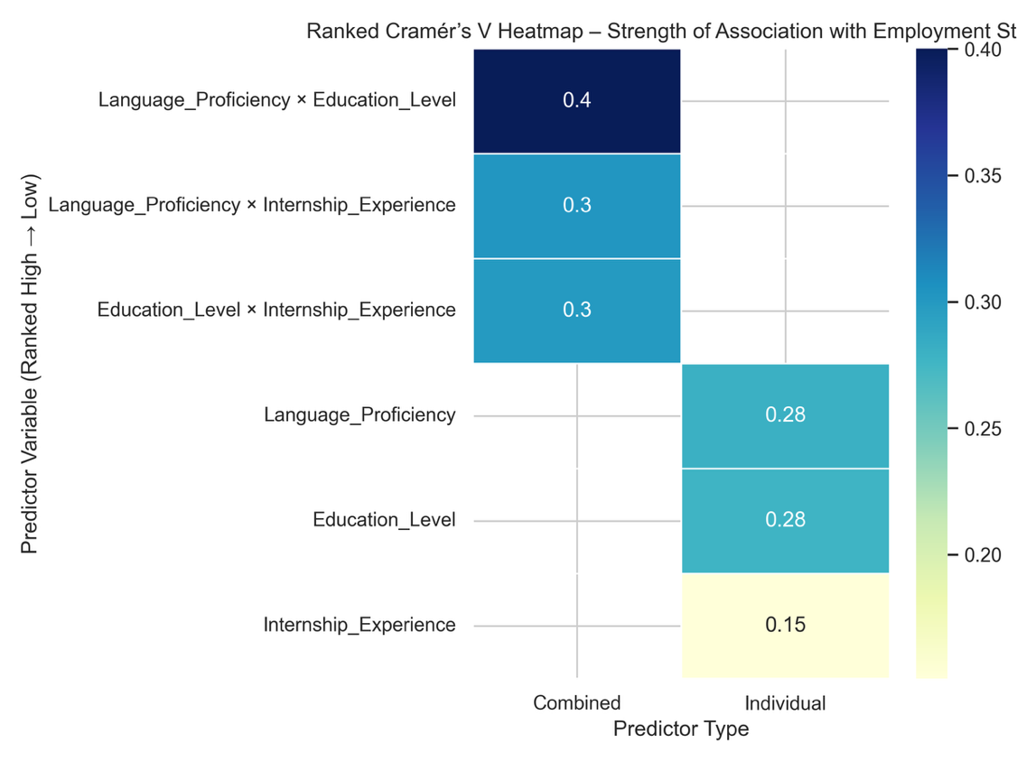
Rank | Predictor | Type | Cramér’s V | Strength
1 | Language × Education | Combined | 0.400 | Strong
2 | Language × Internship | Combined | 0.302 | Moderate
3 | Education × Internship | Combined | 0.299 | Moderate
4 | Language Proficiency | Individual | 0.281 | Moderate
5 | Education Level | Individual | 0.277 | Moderate
6 | Internship Experience | Individual | 0.151 | Weak

Conclusion
All variables are significantly associated with employment outcomes (p < 0.001).
Language Proficiency and Education Level exhibit the strongest independent effects, while internship experience plays a supportive role.
When combined, Language × Education emerges as the most powerful predictor (Cramér’s V = 0.400).
Overall, graduates with advanced language skills, higher education levels, and internship experience show the highest employability.
These results suggest that universities should emphasise both academic development and communication skills, and employers should value practical training as an indicator of job readiness.

